***getDate , getTime , getDay , getMonth TAG:***

***SOURCE CODE:***

<!DOCTYPE html>

<html lang="en">

<head>

<meta charset="UTF-8">

<meta http-equiv="X-UA-Compatible" content="IE=edge">

<meta name="viewport" content="width=device-width, initial-scale=1.0">

<title>Date</title>

</head>

<body>

<p>The Current Date,Month,Year,Day is</p>

<script>

const days=["Sunday","Monday","Tuesday","Wednesday","Thursday","Friday","Saturday"];

const dates=["-","01","02","03","04","05","06","07","08","09","10","11","12","13","14","15","16","17","18","19"

,"20","21","22","23","24","25","26","27","28","29","30","31"];

const year="2023";

const months = ["January","February","March","April","May","June","July","August","September","October",

"November","December"];

const d = new Date();

let date = dates[d.getDate()];

document.write(date);

let month = months[d.getMonth()];

document.write(month);

document.write(year);

let day = days[d.getDay()];

document.write(day);

</script>

</body>

</html>

***OUTPUT:***

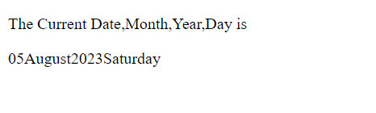

***SOURCE CODE:***

<!DOCTYPE html>

<html lang="en">

<head>

<meta charset="UTF-8">

<meta name="viewport" content="width=device-width, initial-scale=1.0">

<title>Current Date and Time</title>

</head>

<body>

<p>The Current Date and Time is</p>

<p id="current"></p>

<script>

const d = new Date();

document.getElementById("current").innerHTML = d;

</script>

</body>

</html>

***OUTPUT:***

